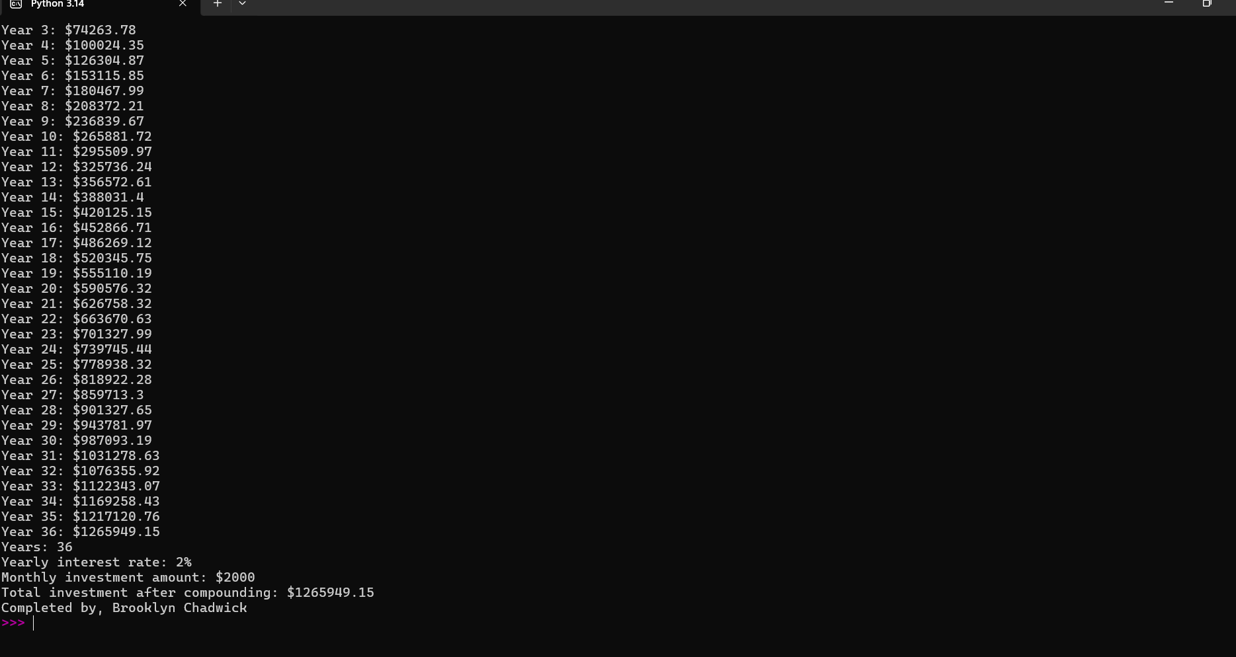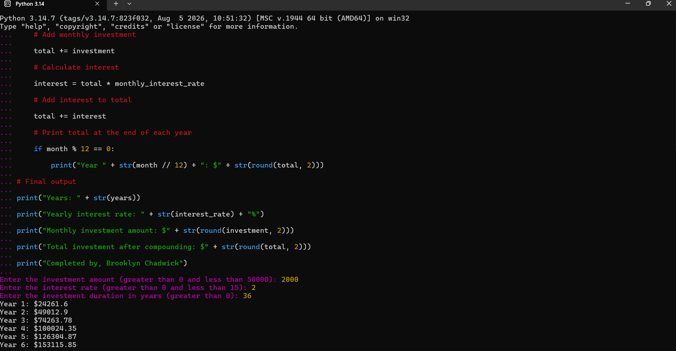
# Investment Calculation
# Get investment amount
investment = int(input("Enter the investment amount (greater than 0 and less than 50000): "))
while investment <= 0 or investment >= 50000:
print("Invalid investment amount. Please enter a value greater than 0 and less than 50000.")
investment = int(input("Enter the investment amount (greater than 0 and less than 50000): "))
# Get interest rate
interest_rate = int(input("Enter the interest rate (greater than 0 and less than 15): "))
while interest_rate <= 0 or interest_rate >= 15:
print("Invalid interest rate. Please enter a value greater than 0 and less than 15.")
interest_rate = int(input("Enter the interest rate (greater than 0 and less than 15): "))
# Get investment duration
years = int(input("Enter the investment duration in years (greater than 0): "))
while years <= 0:
print("Invalid duration. Please enter a value greater than 0.")
years = int(input("Enter the investment duration in years (greater than 0): "))
# Convert years to months
months = years * 12
# Convert yearly interest rate to monthly decimal
monthly_interest_rate = interest_rate / 12 / 100
# Start total at zero
total = 0
# Calculate investment for each month
for month in range(1, months + 1):
# Add monthly investment
total += investment
# Calculate interest
interest = total * monthly_interest_rate
# Add interest to total
total += interest
# Print total at the end of each year
if month % 12 == 0:
print("Year " + str(month // 12) + ": $" + str(round(total, 2)))
# Final output
print("Years: " + str(years))
print("Yearly interest rate: " + str(interest_rate) + "%")
print("Monthly investment amount: $" + str(round(investment, 2)))
print("Total investment after compounding: $" + str(round(total, 2)))
print("Completed by, Brooklyn Chadwick")

